IA. Write a Program to Create a 3X3 Array from User Input. Display the Array in Matrix Format also Display the Values using Subscript.
CODE:
#include<iostream.h>
#include<conio.h>
void main()
{
clrscr();
int i,j,a[3][3];
cout<<"Enter Elements : ";
for(i=0;i<=2;i++)
{
for(j=0;j<=2;j++)
{
cin>>a[i][j];
}
cout<<endl;
}
cout<<"3X3 Matrix: "<<endl;
cout<<endl;
for(i=0;i<=2;i++)
{
for(j=0;j<=2;j++)
{
cout<<a[i][j]<<" ";
}
cout<<endl;
}
cout<<endl;
cout<<"Subscript of Matrix:"<<endl;
cout<<endl;
for(i=0;i<=2;i++)
{
for(j=0;j<=2;j++)
{
cout<<"["<<i<<" "<<j<<"]="<<a[i][j]<<endl;
}
cout<<endl;
}
getch();
}
OUTPUT:
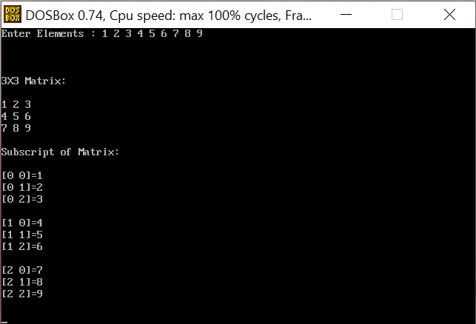

B. Write a Program to Perform Addition of Two 3X3 Matrix. Display the Values. [User Input]
CODE:
#include<iostream.h>
#include<conio.h>
void main()
{
clrscr();
int i,j,a[3][3],b[3][3],c[3][3];
cout<<"Enter Elements for Matrix 1: ";
for(i=0;i<=2;i++)
{
for(j=0;j<=2;j++)
{
cin>>a[i][j];
}
cout<<endl;
}
cout<<"Matrix 1 : "<<endl;
cout<<endl;
for(i=0;i<=2;i++)
{
for(j=0;j<=2;j++)
{
cout<<a[i][j]<<" ";
}
cout<<endl;
}
cout<<endl;
cout<<"Enter Elements for Matrix 2: ";
for(i=0;i<=2;i++)
{
for(j=0;j<=2;j++)
{
cin>>b[i][j];
}
cout<<endl;
}
cout<<"Matrix 2 : "<<endl;
cout<<endl;
for(i=0;i<=2;i++)
{
for(j=0;j<=2;j++)
{
cout<<b[i][j]<<" ";
}
cout<<endl;
}
cout<<endl;
cout<<"Addition of Matrix 1 & Matrix 2: "<<endl;
cout<<endl;
for(i=0;i<=2;i++)
{
for(j=0;j<=2;j++)
{
c[i][j]=a[i][j]+b[i][j];
cout<<c[i][j]<<" ";
}
cout<<endl;
}
cout<<endl;
getch();
}
OUTPUT:
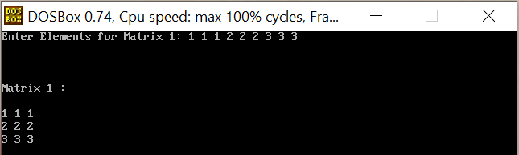
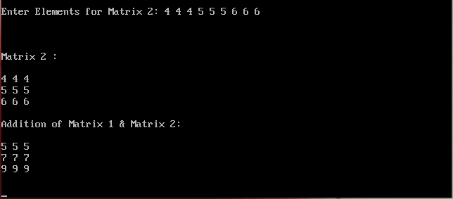

C. Write a Program to Display the Transpose of a 4X4 Matrix.
CODE:
#include<iostream.h>
#include<conio.h>
void main()
{
clrscr();
int i,j,a[4][4];
cout<<"Enter Elements : ";
for(i=0;i<=3;i++)
{
for(j=0;j<=3;j++)
{
cin>>a[i][j];
}
cout<<endl;
}
cout<<"4X4 Matrix: "<<endl;
cout<<endl;
for(i=0;i<=3;i++)
{
for(j=0;j<=3;j++)
{
cout<<a[i][j]<<" ";
}
cout<<endl;
}
cout<<endl;
cout<<"Transpose of the Matrix: "<<endl;
cout<<endl;
for(j=0;j<=3;j++)
{
for(i=0;i<=3;i++)
{
cout<<a[i][j]<<" ";
}
cout<<endl;
}
cout<<endl;
getch();
}
OUTPUT:
